Auto PPT Maker v1.01

<https://sfuca0-my.sharepoint.com/:f:/g/personal/yja47_sfuca0_onmicrosoft_com/EmPIpyyjx-9At1LiqXHcaEABjguctlzF4UL5_rumNnfSCg?e=OsBhLP>

**What is this?**

The, tentatively named, “Auto PPT Maker” is designed to generate “perfectly” formatted **stream** and **projected** PPTs. However, the program is still under development. For now, to obtain an auto-generated PPT, you should download the “SlideInputs.txt” file at the above link, edit the file with your desired parameters, return the file to David (preferably on Messenger), and he will send you the generated PPT.

**What features are not yet available?**

* Announcement Slides
* Catechism Slides
* Next Week Schedule Slides
* Slides with multiple bible verses from different sources

**I don’t get it ¯\_(ツ)_/¯**

Message David on Facebook Messenger if you have any questions or concerns.

**How To:**

1. Download “SlideInputs.txt” via the above link

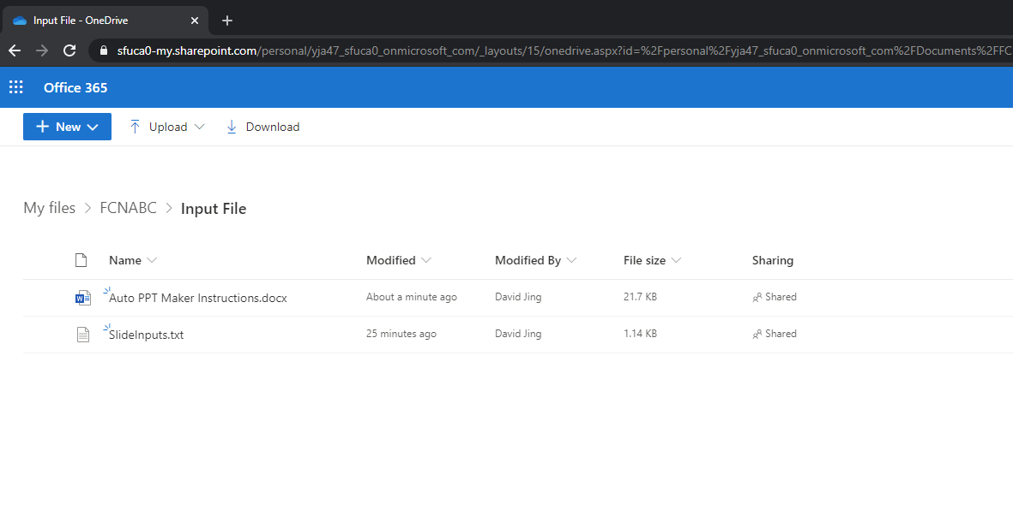

1. Open the file via Notepad: *Right click file* –> *Open with* –> *Notepad*

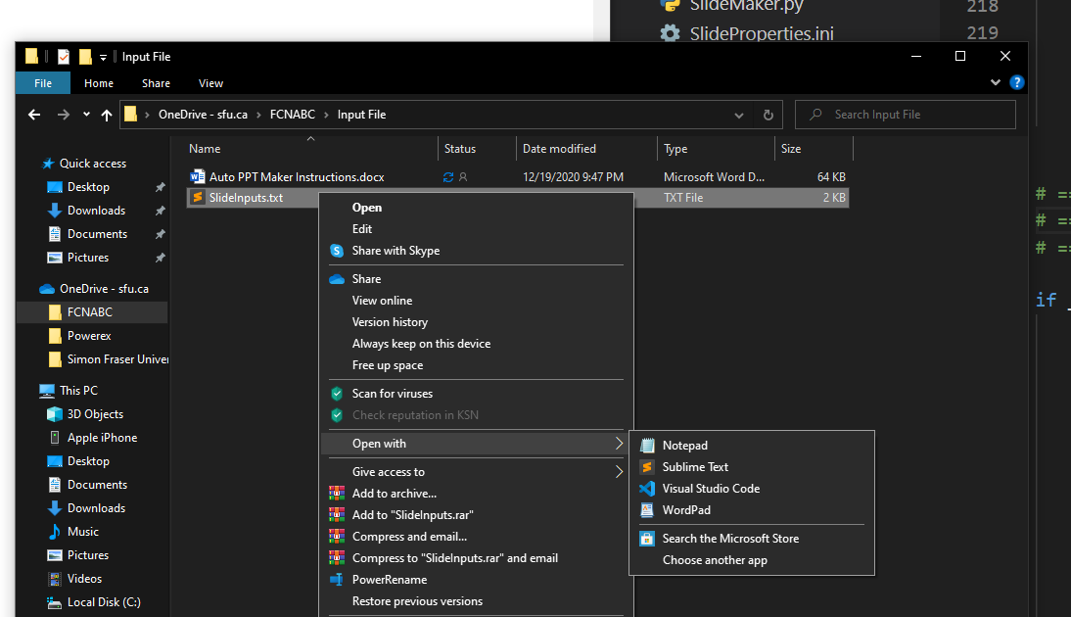

1. Edit the file (the parameters of interest are highlighted in green):

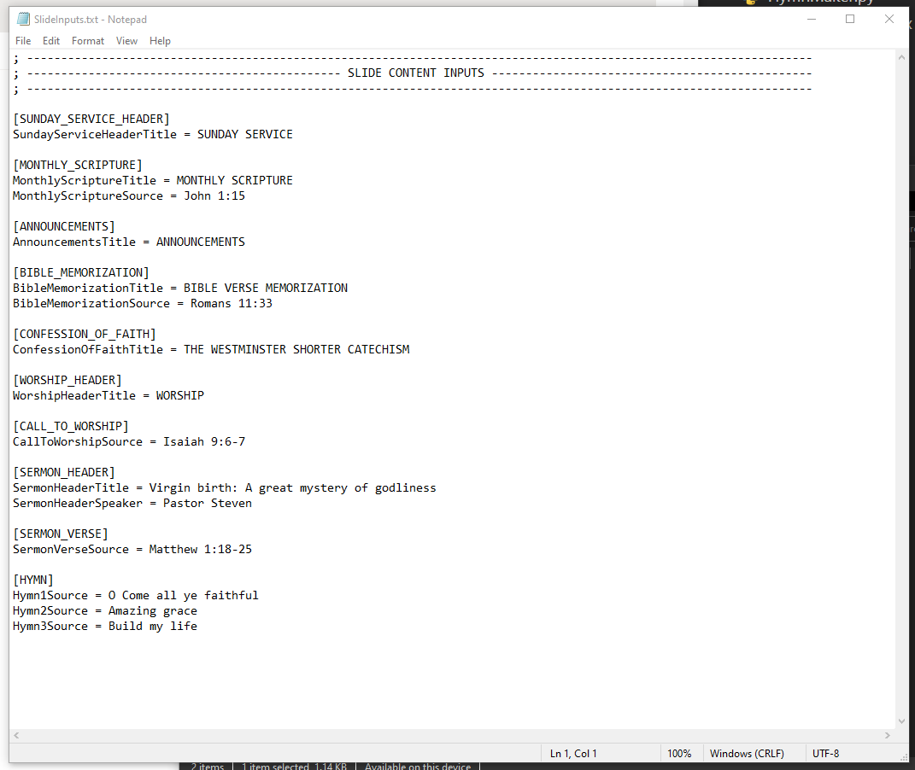

Please replace the existing inputs (i.e. right side of “CallToWorshipSource = ”) with your own. With development, the above image might not accurately reflect what you currently observe; however, the mythology remains the same. I hope the variable names are self-explanatory; if you don’t know, ask David.

**What Can I Enter?**

Each variable can accept a range of inputs (typos can work too…).

Proper capitalization of the inputs is not necessary.

Note that inputted text should NOT span multiple lines; the entire input must exist on the same line as the variable (i.e. “SermonVerseSource”).

**PLEASE DO NOT DELETE OR CHANGE THE VARIABLE NAMES OR THE HEADER.**

For verses, here are the possible input variations:

* *Ephesians 6* (returns the entire chapter 6 of Ephesians)
* *Genesis 1:1-10* (returns verses 1 to 10 of chapter 1 of Genesis)
* *1 John 3:11-* (returns everything from verse 11 to end of chapter 3 of 1 John)

(Note: Multi-source verses are not yet available)

For hymns, here are some possible inputs:

* Doxology
* Guren no Yumiya (😊)